# MUHAMMAD TAYYAB 22-ARID-945 BSSE 4A Morning To => Ms Aimen

___________________________________________________________________________________

**Question # 1 Create a Page of Something You are Passionate of**.  
  
Link view live => https://web-page-of-my-interest.vercel.app/

Screenshot:

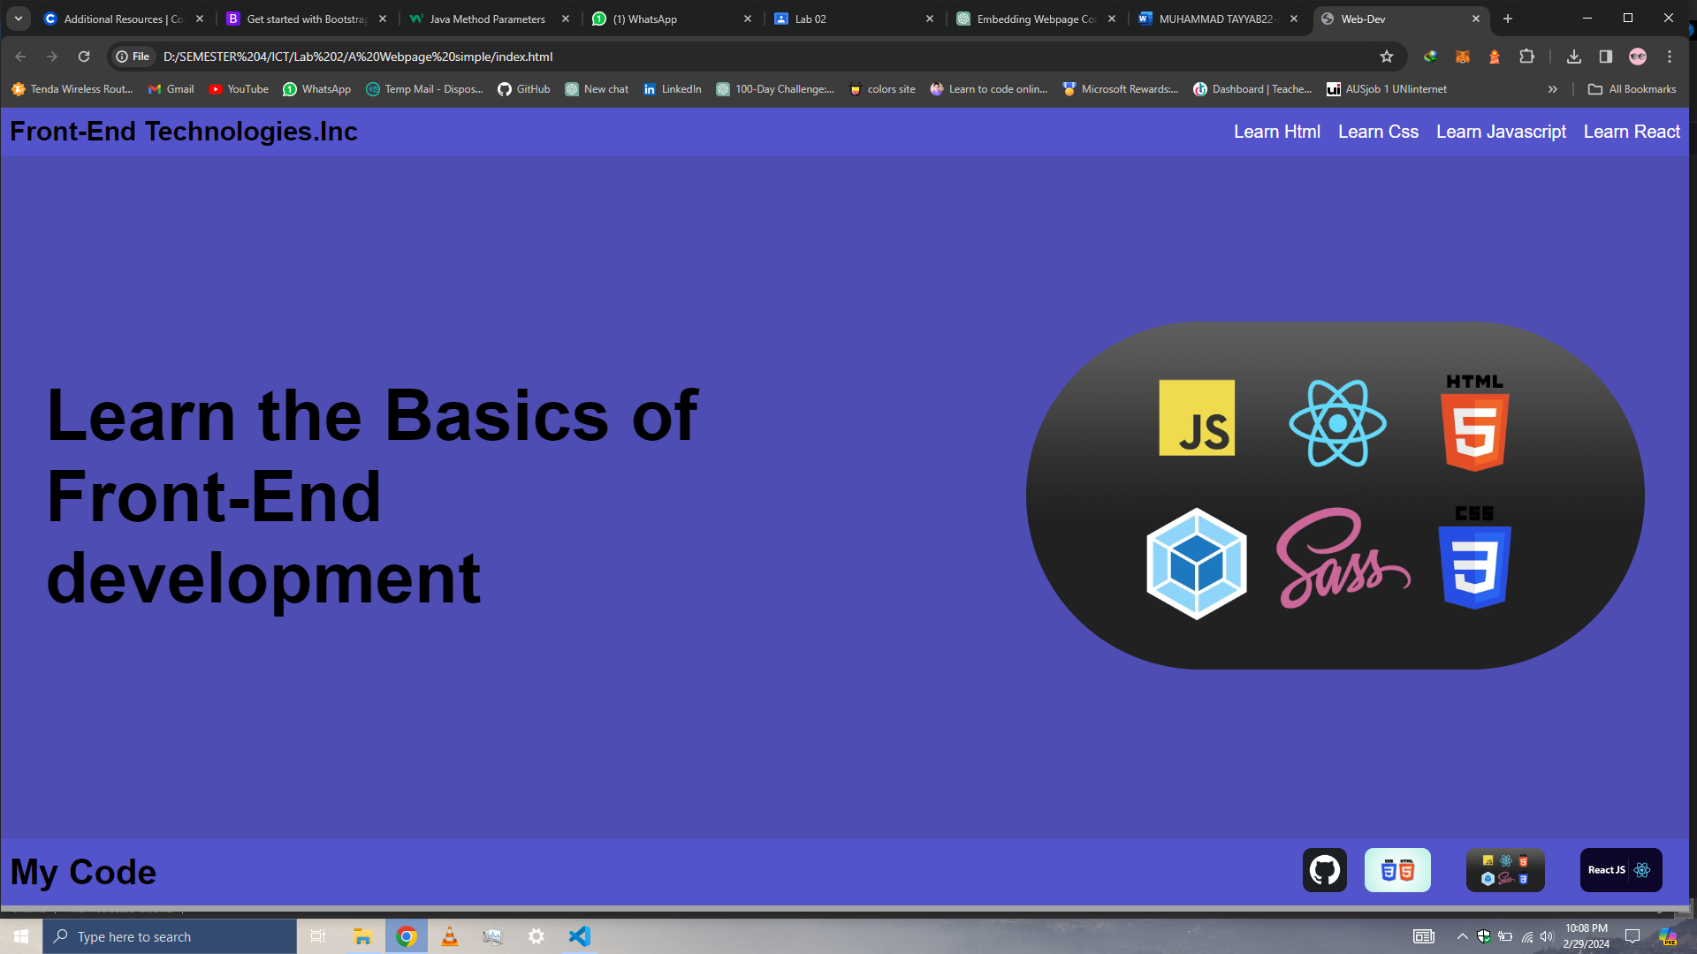

_____________________________________________________________________________________

____________________________________________________

QUESTION # 2. Create a new blank page with just a header (“All About Your Interests”).

a. Embed a WebPage of Your Choice

b. Add Your Google Calendar

c. Add a YouTube Video that you Like the most

d. Embed SoundCloud Sound of Your Interest!

Link view live => https://html-code-embeding-tut.vercel.app/

Screenshot:

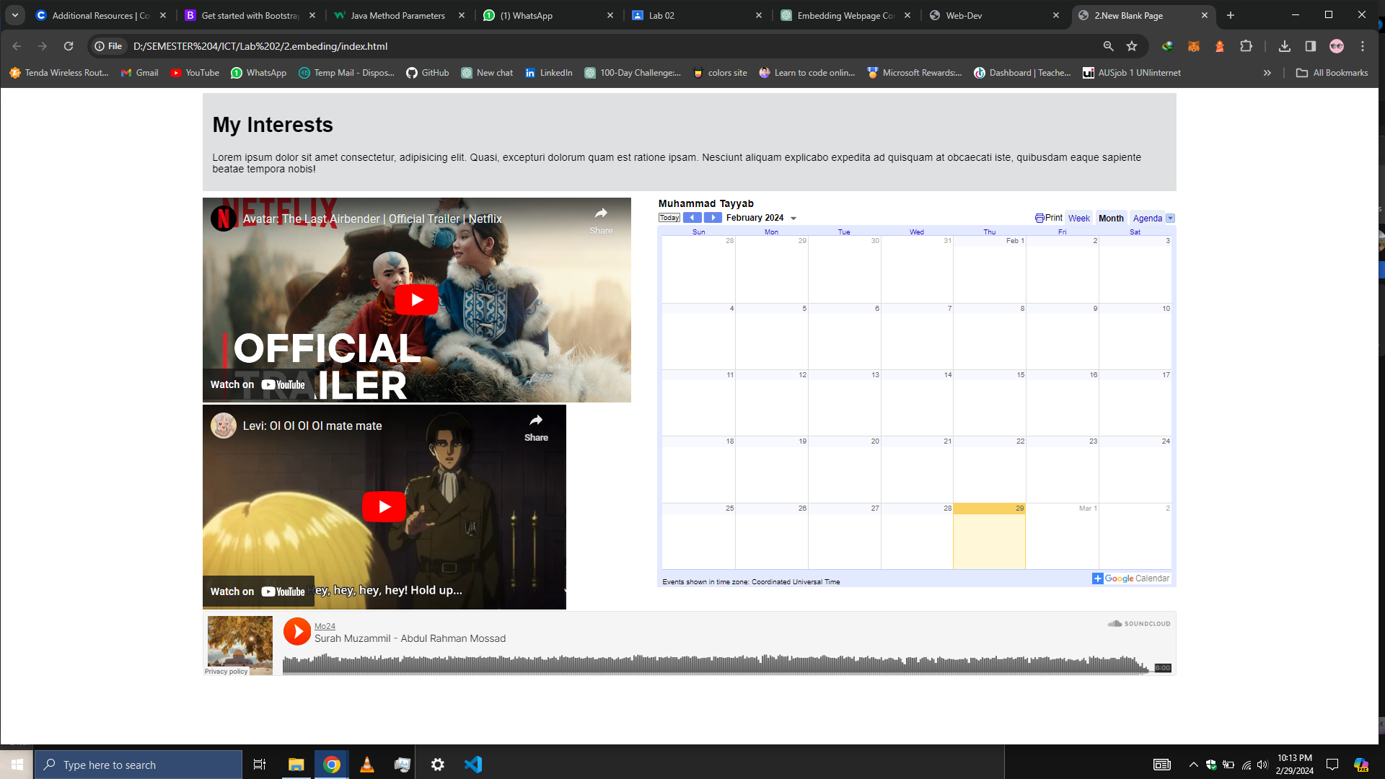

__________________________________________________

__________________________________________________

QUESTION # 3 and 4 The tags which we have studied use those to create you CV. CV must contain the following information: a. Personal Information b. Image c. Objective

d. Qualification e. Experience f. Achievements

g. Interests

h. Note:Must use hyperlink

Create one table with (Snapshot below):

Link view live => https://cv-with-html-and-css-rho.vercel.app/

Screenshot:

